
Total marks  43 | % | Weight  10%
My Target: ____ /43 or _____%  

Name: _______________________

Yr 7 Humanities & Social Sciences:

Task Seven:

Civics and Citizenship

Assessment 7: Homework Task (10%)

Civics and Citizenship: A series of questions to be completed by students, in relation to current course content.

Due Date: __________May 2017

Instructions:
- Please attempt all questions.
- Look at the question and determine if the space provided is requiring a full sentence answer.
- Remember to include examples where appropriate – Please avoid stating e.g. and use “for example”. If you use examples, remember to include examples within your explanation, instead of simply adding the example to the end.

- On the following map of Australia colour the States and Territories of Australia using the following colouring scheme: unicameral states/territories in blue and bicameral states/territories in red. PLEASE DO NOT USE TEXTAS WHEN COLOURING YOUR MAP. Remember to use BOLTSS.
(8 marks)
Title:

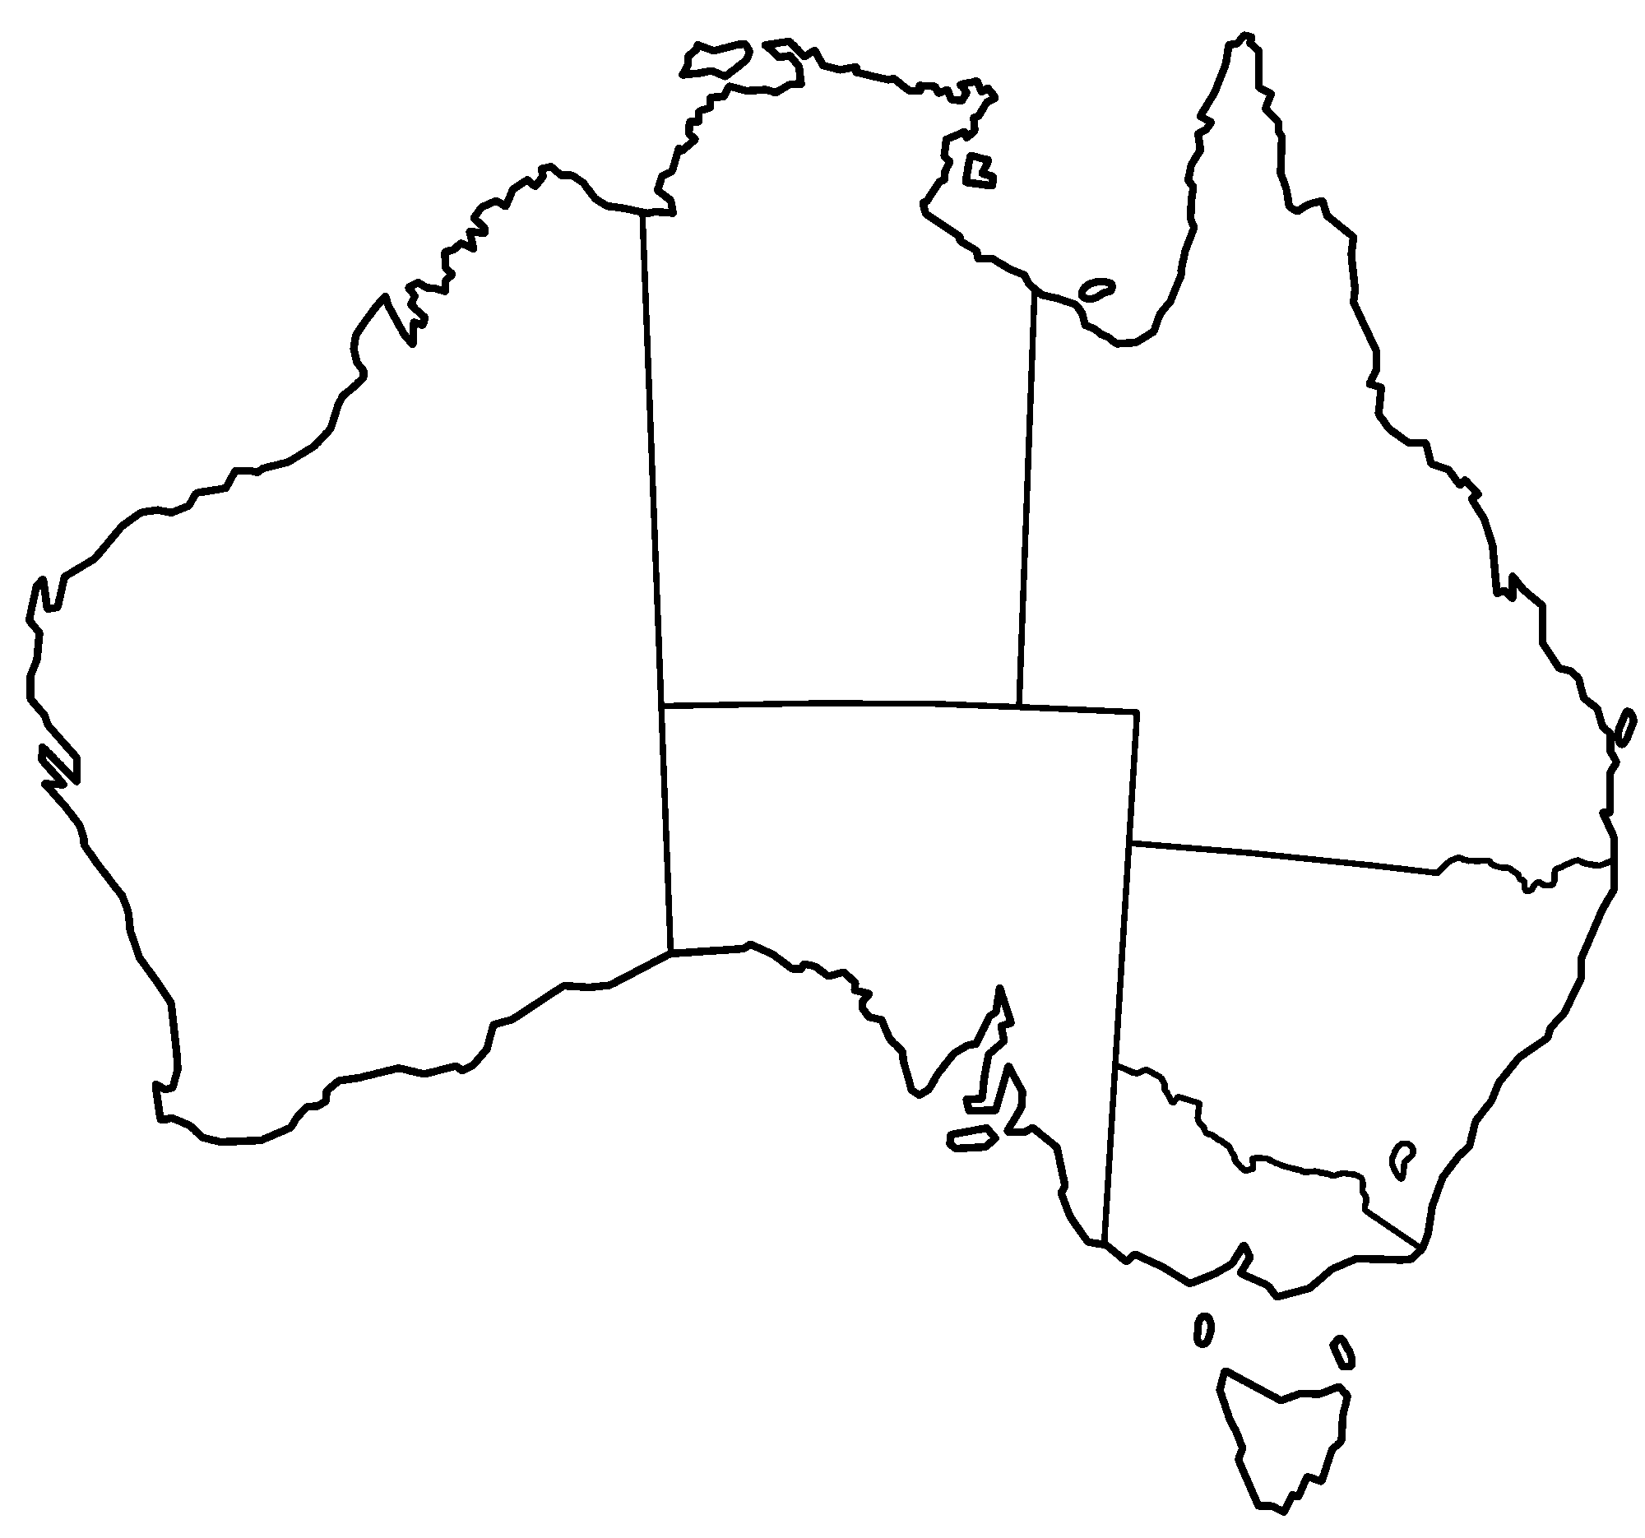

Key:





N

Key:





- List the eight states and territories of Australia. State whether they are bicameral or unicameral and state the names of the houses of Parliament. (24 marks)
Name of State or Territory  (Write the full name) | Bicameral or Unicameral | Name the House(s) of Parliament
- Define the term bicameral. A good answer will use full sentences and includes relevant examples. (2 marks)
____________________________________________________________________________
____________________________________________________________________________
- Define the term unicameral. A good answer will use full sentences and includes relevant examples. (2 marks)
____________________________________________________________________________
____________________________________________________________________________
- Outline two key features of the Senate. (2 marks)
Key feature 1: ______________________________________________________________
__________________________________________________________________________

Key feature 2: ______________________________________________________________
__________________________________________________________________________

- Outline two key features of the House of Representatives. (2 marks)

Key feature 1: ______________________________________________________________
__________________________________________________________________________

Key feature 2: ______________________________________________________________
__________________________________________________________________________

- Describe why Australia uses the Westminster System of Government. A good answer will use full sentences and include relevant examples. (3 marks)

____________________________________________________________________________
____________________________________________________________________________
____________________________________________________________________________
____________________________________________________________________________
____________________________________________________________________________
____________________________________________________________________________
____________________________________________________________________________
____________________________________________________________________________
End of Homework Task

